REPUBLIQUE DU CAMEROUN REPUBLIC OF CAMEROON

Paix-travail-patrie Peace-work-fatherland

MINISTERE DE L’ENSEIGNEMENT MINISTRY OF HIGHER EDUCATION

SUPERIEUR





**PROJECT**

GESTION DE STOCK

**PRESENTE PAR :**

**NJIKI NANA CHRISTIAN**

**3IL 5**

**ENSEIGNANT:**

**M. NGANKAM SEVERIN**

ANNEE ACADEMIC

2021 – 2022

**Login and Registration**

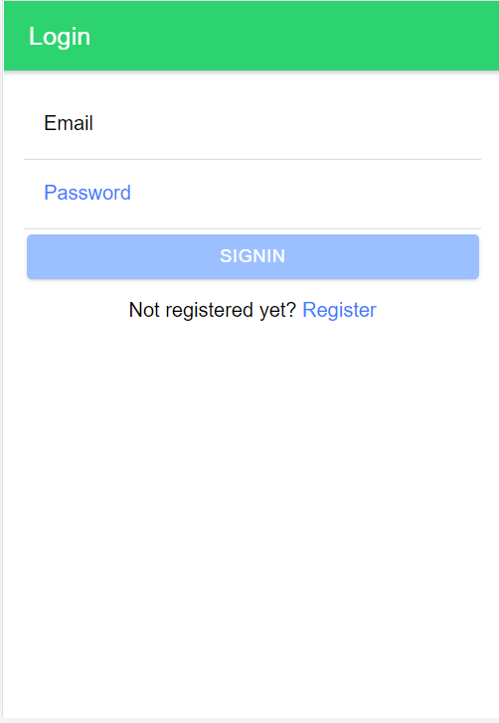 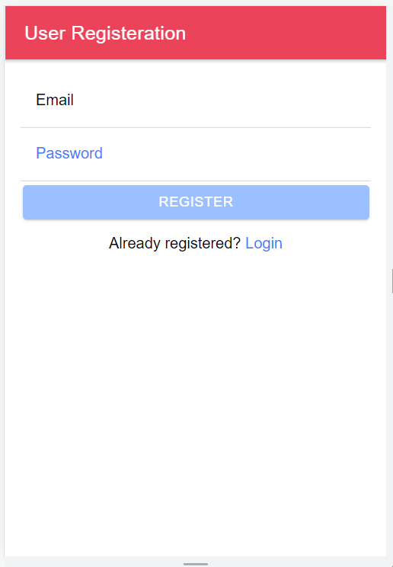

**Credentials stored in firebase authentification module**

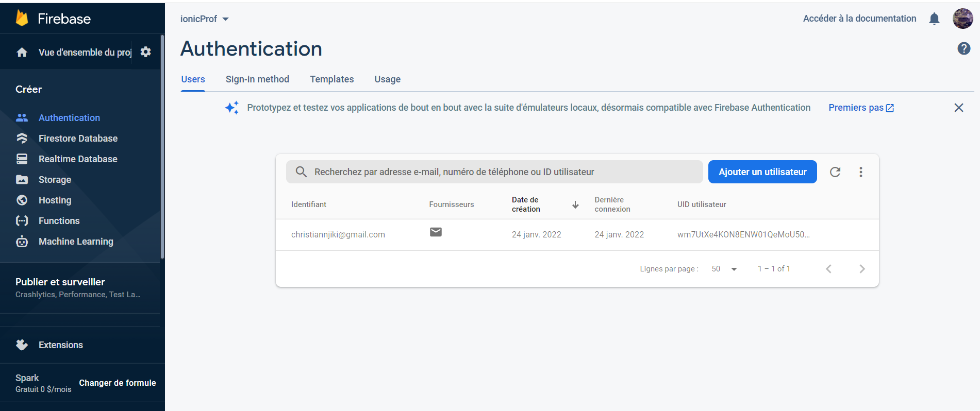

**Adding a new product**

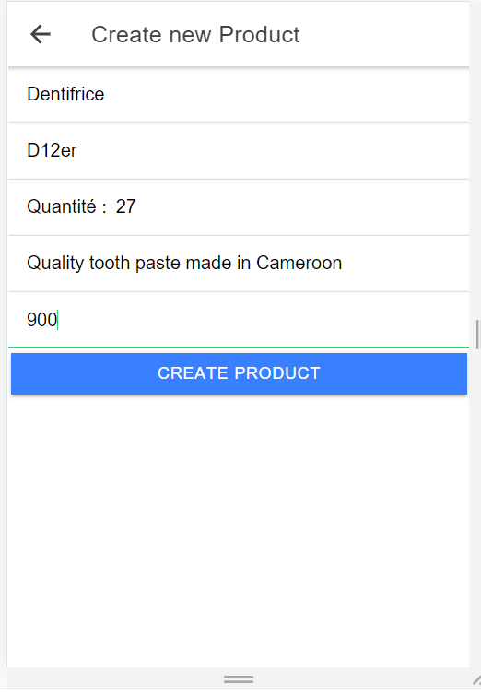 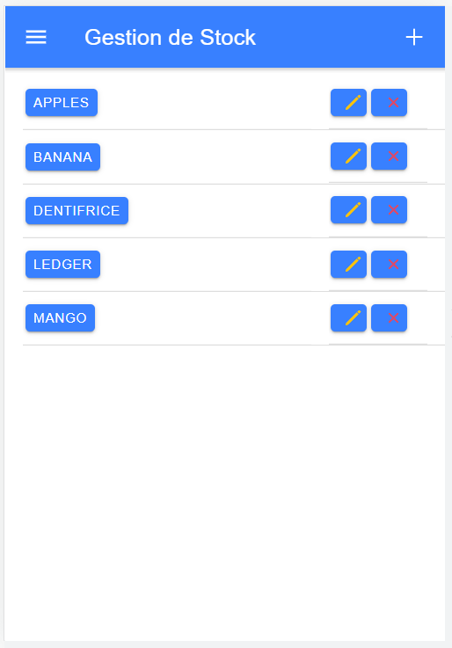

**New product added to firestore**

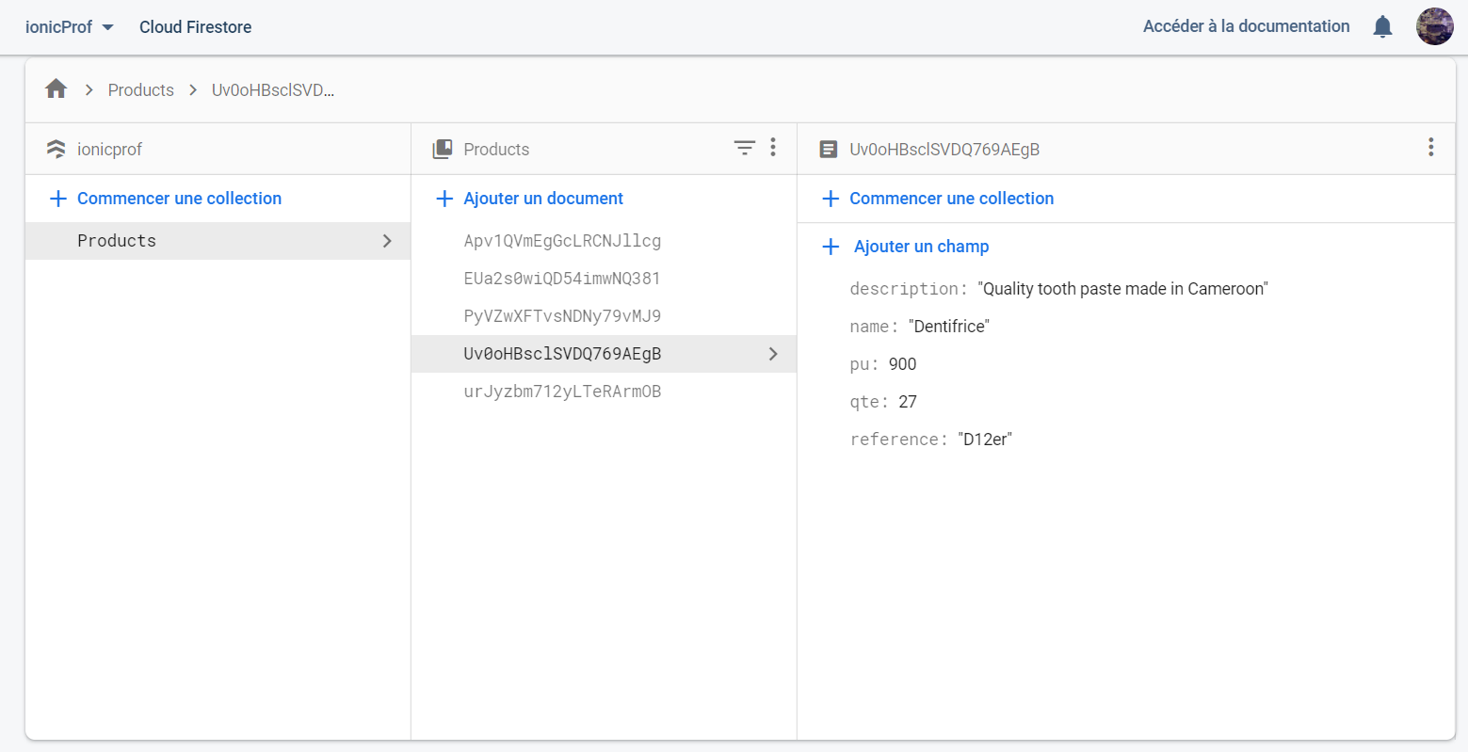

**Editing product details**

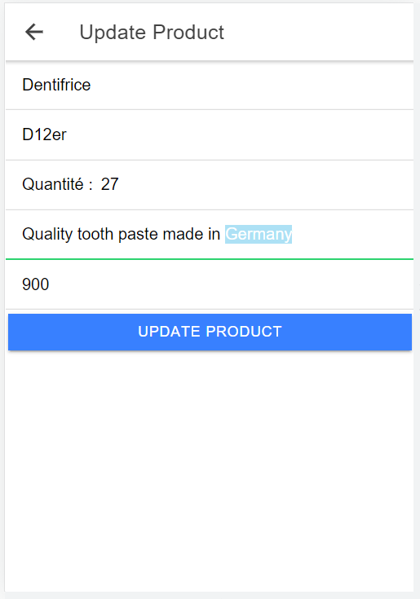

**Product information edited in firestore**

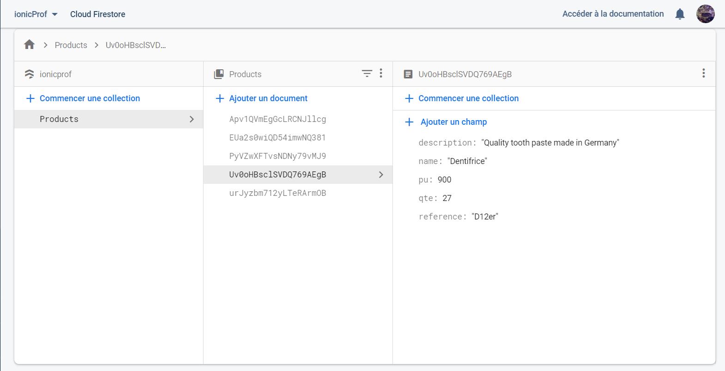

**Deleting Product**

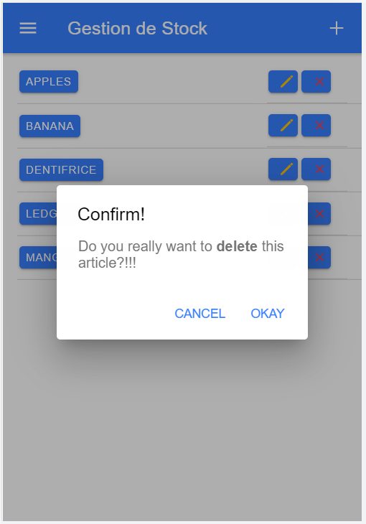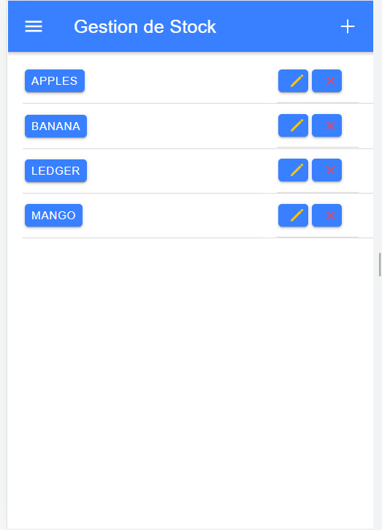

**Product deleted from firestore (Notice we now have 4 products instead of 5)**

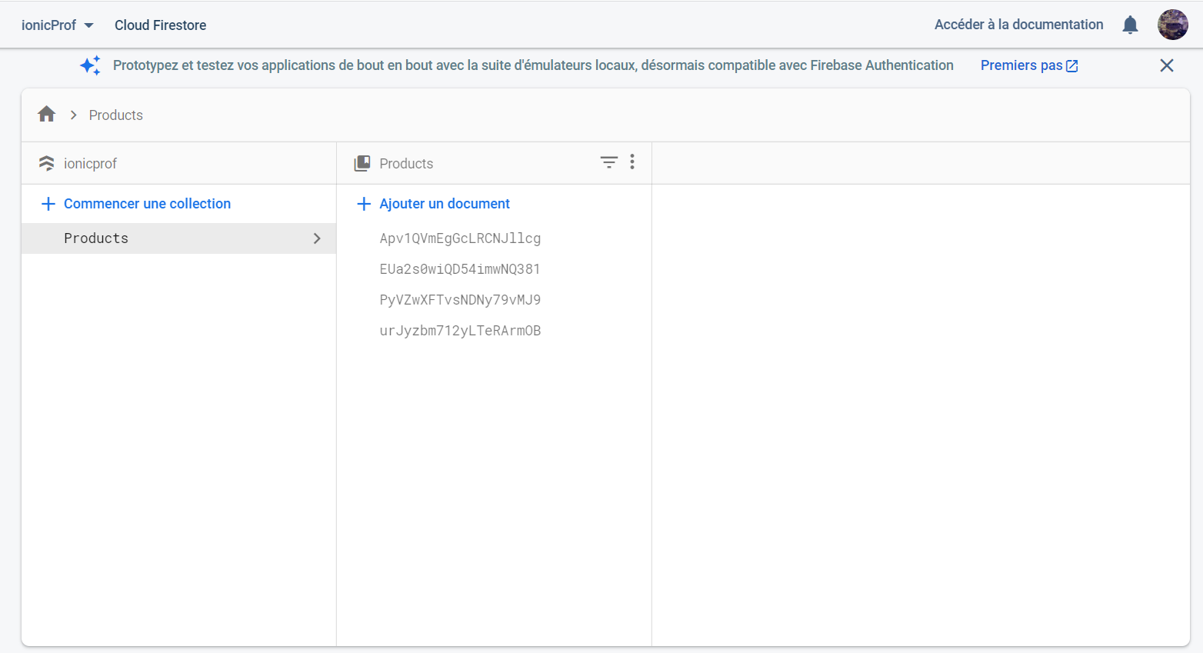

**Viewing product details**

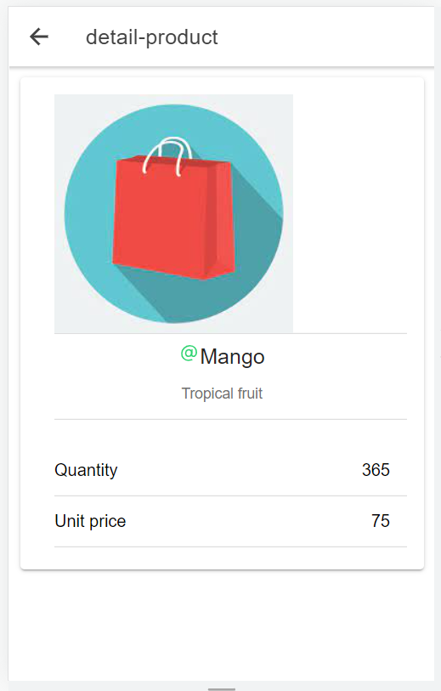

**Unfortunately, we already deleted “Dentifrice”**

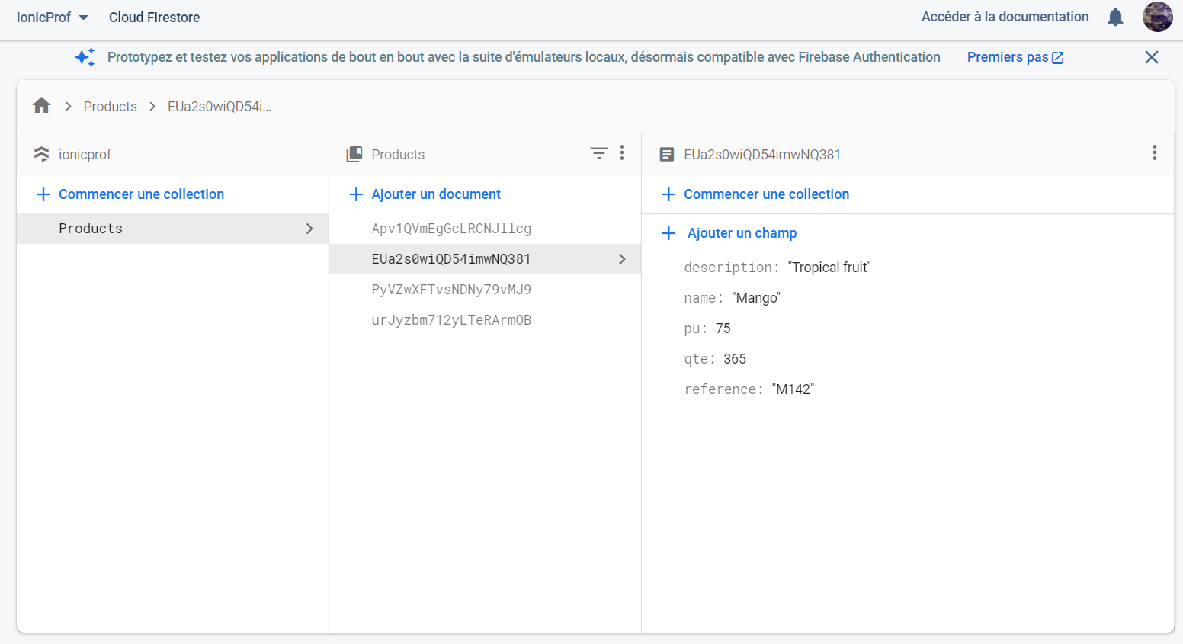

**Navigation Sidebar GPS Page to get the current location**

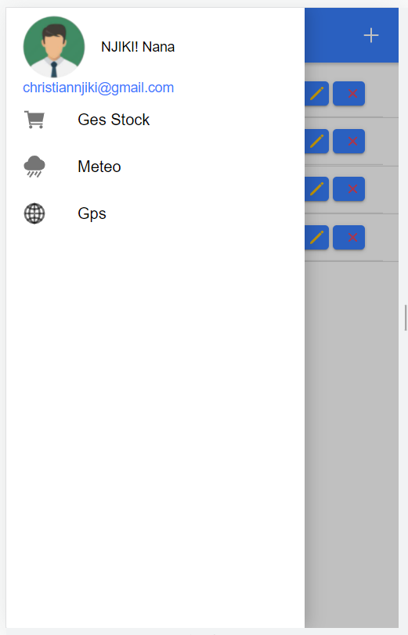 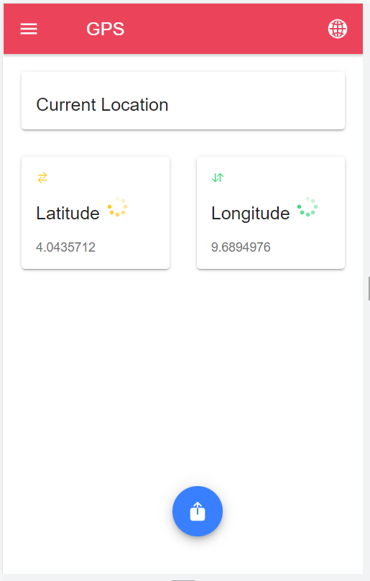

**Coordinates stored in browser > Aplication > indexdB**

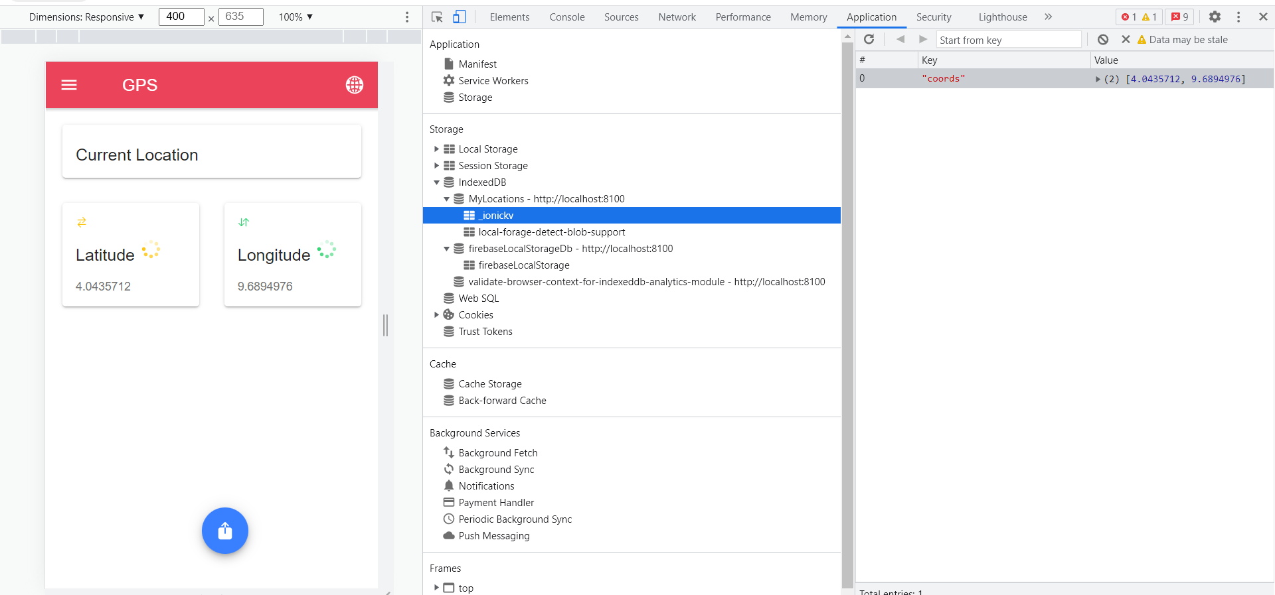

**Meteo Page When show more is clicked**

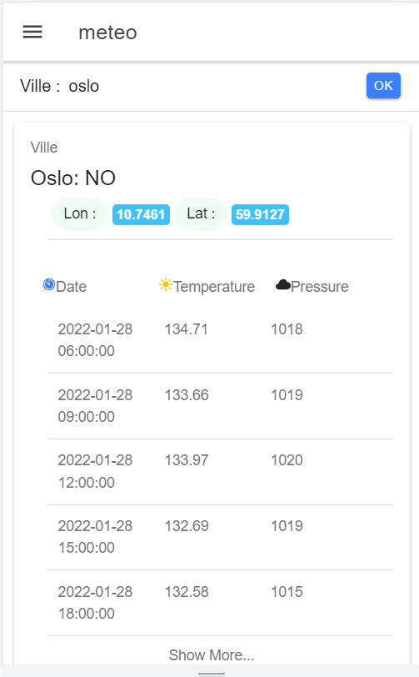 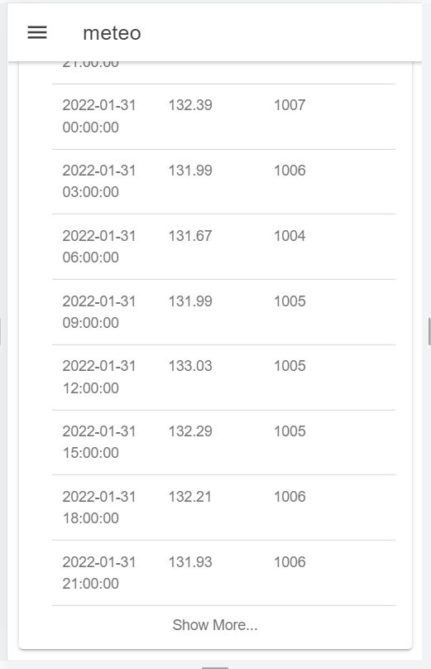

**When all information available is displayed**

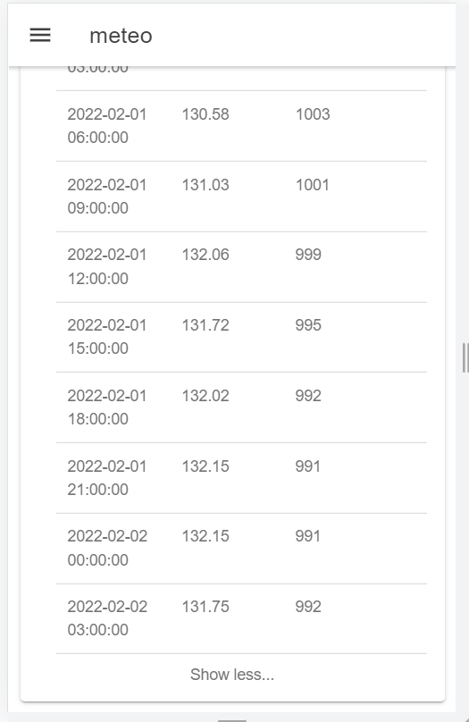

**Firebase Service**

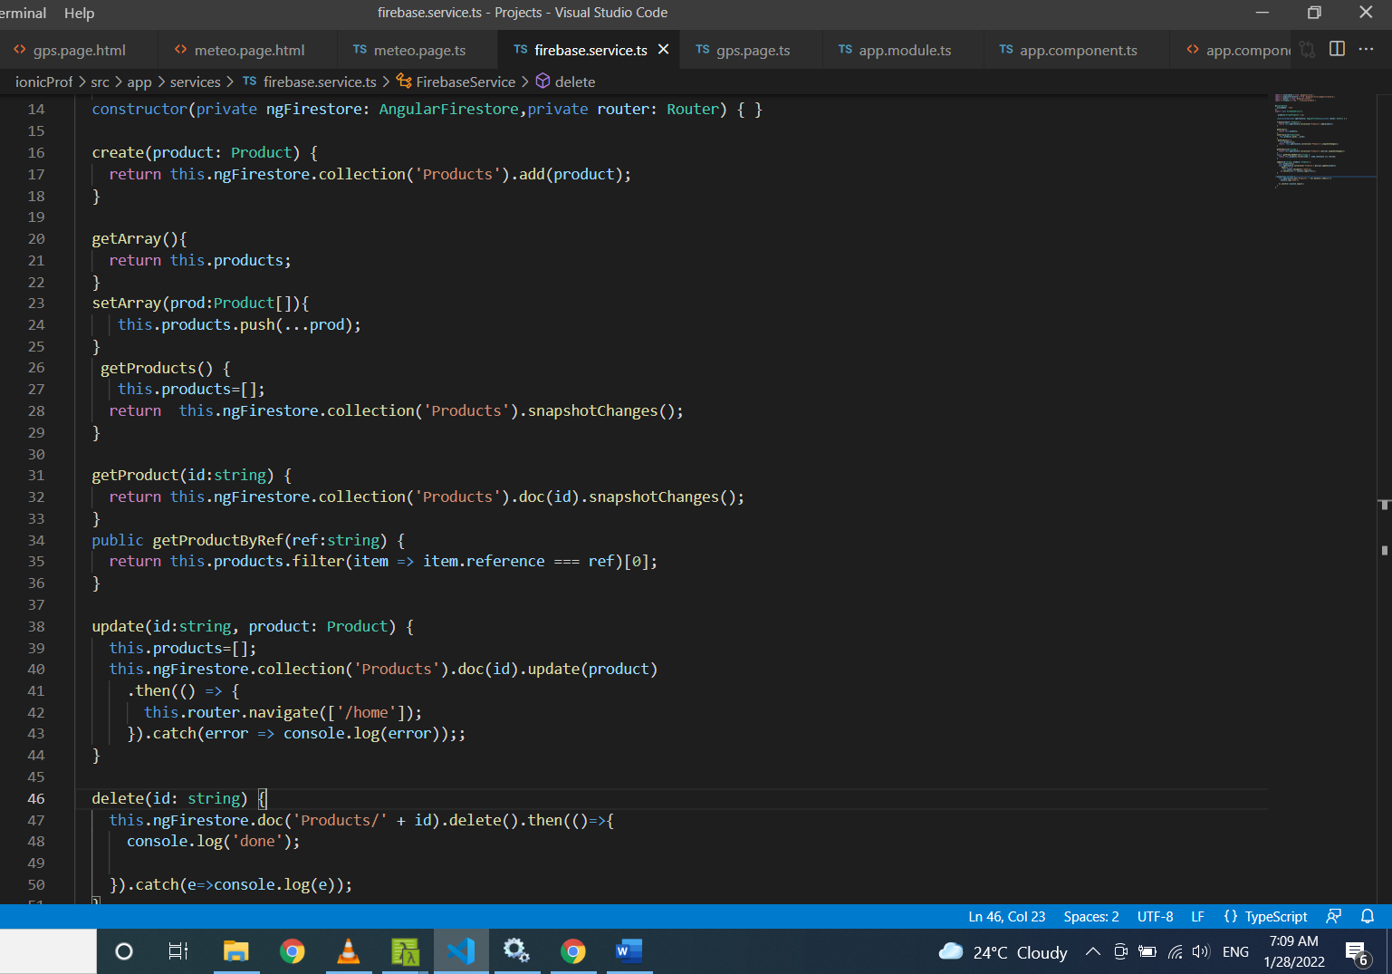

[**Home.page.ts**](http://Home.page.ts)

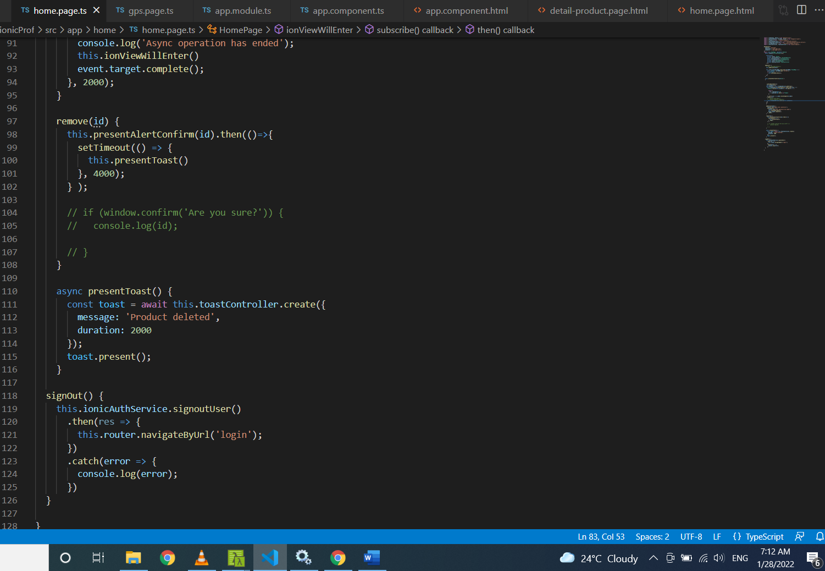

**Conclusion**

This project has helped add new skills to my portfolio I think i will import this project to my github thanks enormously sir.